*Use the information in Chapter 5 (p. 68-89) to complete the following reading guide. The following Bozeman podcasts are also helpful:* [*Molecules of Life*](http://www.bozemanscience.com/molecules-of-life) *and* [*Biological Molecules*](http://www.bozemanscience.com/042-biologoical-molecules)*.*

**Concept 5.1: Macromolecules are polymers, built from monomers**

1. Describe the relationship between monomers and polymers and give two examples.
2. Explain what reactions are occurring in each of the below diagrams and how they relate to monomers and polymers.

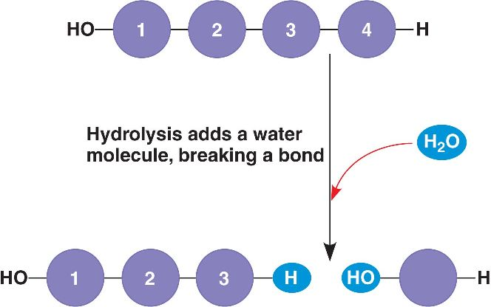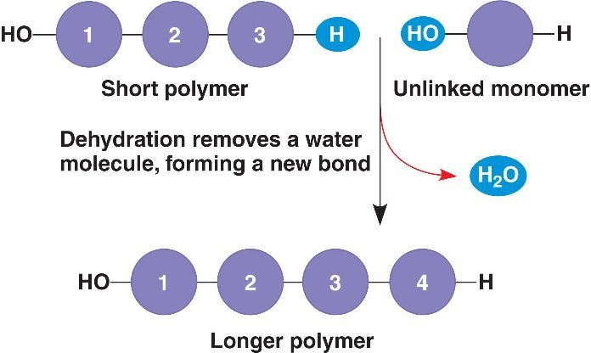

1. Why is it crucial that organisms have the ability to break down polymers as well as build polymers? (Hint: Think about how these reactions relate to digestion)

**Concept 5.2: Carbohydrates serve as fuel and building material**

*Bozeman has a podcast specifically on* [*carbohydrates*](http://www.bozemanscience.com/carbohydrates) *if you want to check it out.*

1. Draw a linear molecule of glucose (Figure 5.3) and highlight the functional groups found within the structure. Predict what properties this gives carbohydrates.
2. Draw a dehydration synthesis reaction between two carbohydrate monomers to form a disaccharide (Figure 5.5). Label the resulting bond that forms.
3. Compare and contrast the structure and function of glycogen and starch.

|  |  |  |
| --- | --- | --- |
| Glycogen | Both | Starch |
|  |  |  |

1. Compare and contrast the structure and function of chitin and cellulose.

|  |  |  |
| --- | --- | --- |
| Chitin | Both | Cellulose |
|  |  |  |

**Concept 5.3: Lipids are a diverse group of hydrophobic molecules**

*Bozeman has a podcast specifically on* [*lipids*](http://www.bozemanscience.com/lipids) *if you want to check it out.*

1. Describe the reaction that is taking place in the below diagram and identify the type bond that is being formed.

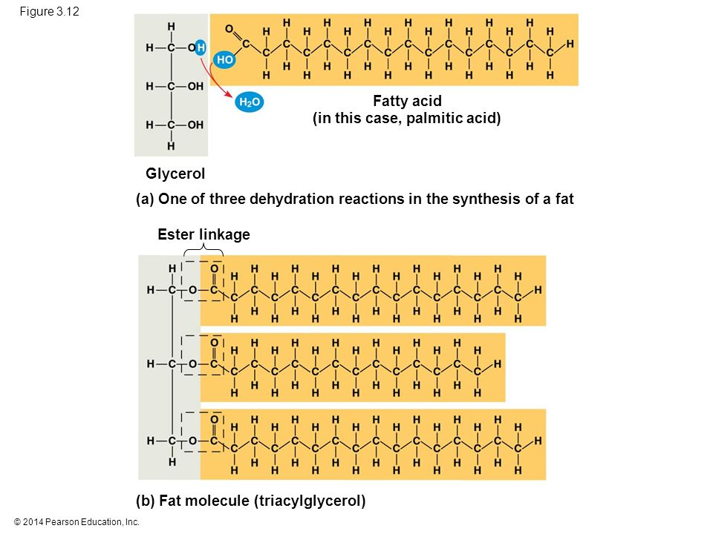

1. Highlight the functional groups that are found in the resulting triglyceride in the above diagram. What properties do these functional groups give this molecule?
2. Explain the difference between saturated and unsaturated fats. (HINT: Focus on the role of hydrogen.)
3. Draw a phospholipid and highlight the functional groups found within (Figure 5.12). Explain how these functional groups result in the formation of a lipid bilayer (Figure 5.13).

**Concept 5.3: Proteins include a diversity of structures, resulting in a wide range of functions**

*Bozeman has a podcast specifically on* [*proteins*](http://www.bozemanscience.com/proteins) *if you want to check it out.*

1. How do enzymes work as a catalyst?
2. Describe at least 3 examples of the different functions of proteins.

|  |  |  |
| --- | --- | --- |
| Function | Diagram | Explanation |
|  |  |  |
|  |  |  |
|  |  |  |

1. Label the diagram of an amino acid. Explain the significance of the amino group and carboxyl group vs. the R-group.

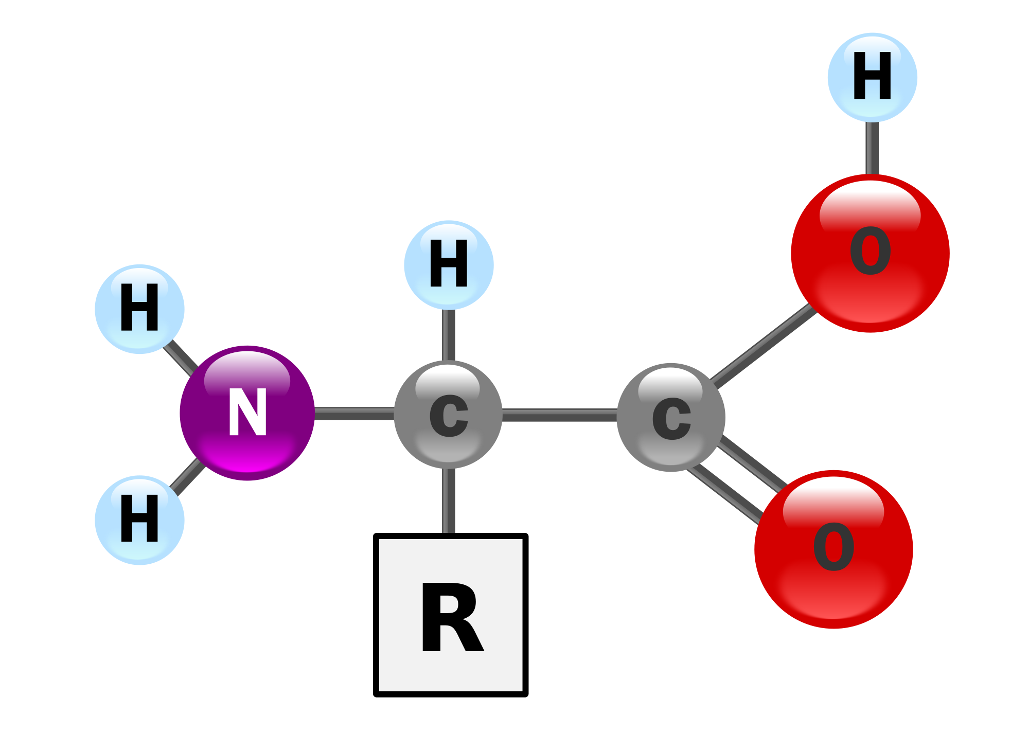

1. Draw a diagram showing two amino acids being joined by a peptide bond in a dehydration synthesis reaction (Figure 5.17).
2. Explain the relationship between amino acids, polypeptides, and proteins.

**Concept: 5.5: Nucleic Acids store, transmit, and help express hereditary information**

*Bozeman has a podcast specifically on* [*nucleic acids*](http://www.bozemanscience.com/nucleic-acids) *if you want to check it out.*

1. Summarize the flow of genetic information.
2. Label the diagram of an amino acid. Predict what kind of reaction joins nucleotides together to form a new strand of DNA or RNA.

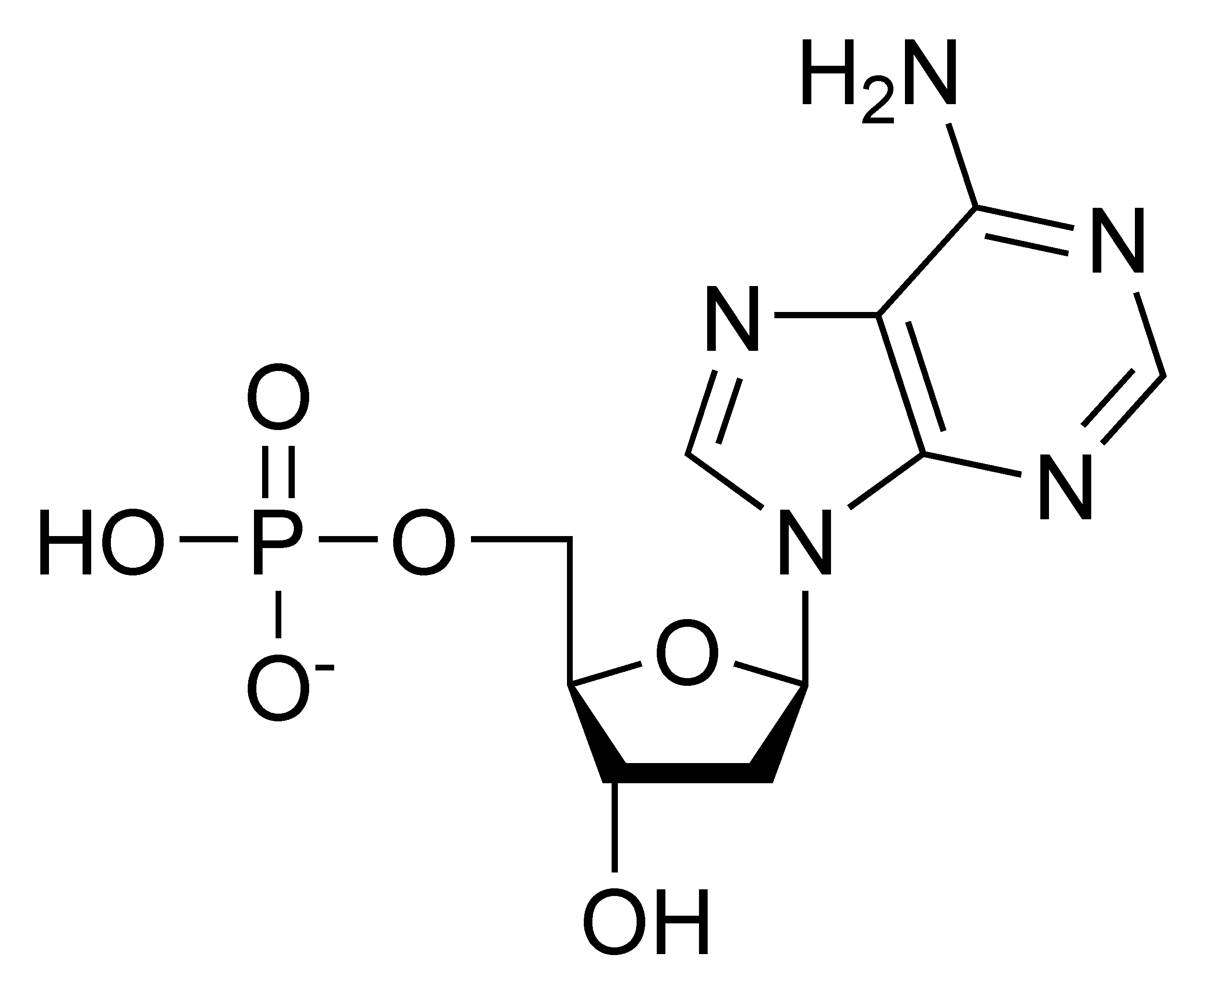

1. Contrast the following sets of structures:

* pyrimidine/purine
* deoxyribose/ribose

1. Compare and contrast the structure and function of DNA and RNA.

|  |  |  |
| --- | --- | --- |
| DNA | Both | RNA |
|  |  |  |